AE86 OEM SEATS

AE86 GTS (USA Model) Seat Information
Submitted and complied by Richard White (quickly becoming THE GURU)
The following information is for those interested in restoring or repairing their GTS Seat. Many of the parts are now becoming increasing difficult to get at a reasonable price. Though a replacement high performance racing seat is superior in strength, it may not match your budget or the look that would fit in the Toyota museum. I have tried to copy the information as best I can, but please beware that mistakes can and do occur. Please consult our Toyota parts department for independent verification and notice the last two digits. That is the color. And again this list is not comprehensive for all models of AE86s.
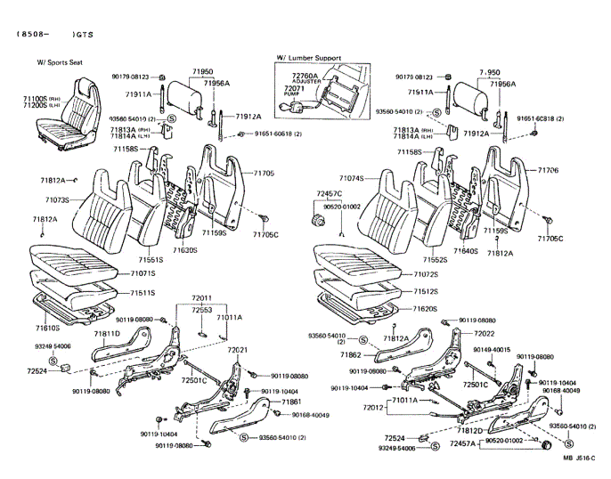
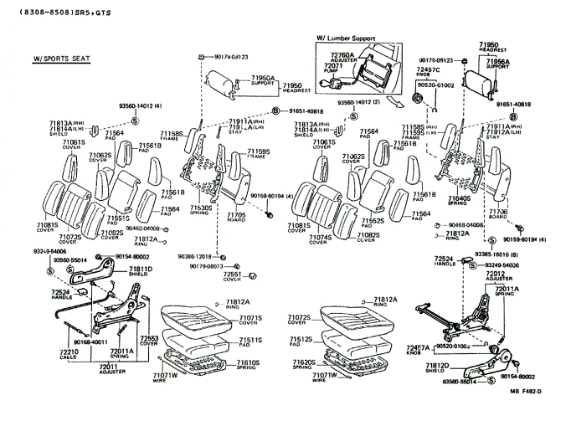
71061S Cover Sub-Assy, Front Seat Back, Upper RH
Prod. Date | Model | Description | Part Number | Qty.
8408-8508 | AE86.. GTS | Deep Maroon | 71061-12010-02 | 2
8408-8508 | AE86.. GTS | Grey | 71061-12010-03 | 2

71062S Cover Sub-Assy, Front Seat Back, Upper LH
Prod. Date | Model | Description | Part Number | Qty.
8408-8508 | AE86.. GTS | Deep Maroon | 71062-12010-02 | 2
8408-8508 | AE86.. GTS | Grey | 71062-12010-03 | 2

71071S Cover, Front Seat Cushion, RH
Prod. Date | Model | Description | Part Number | Qty.
8408-8508 | AE86.. GTS | FB, Deep Maroon | 71071-1E490-02 | 1
8408-8508 | AE86.. GTS | FB, Grey | 71071-1E490-03 | 1
8508-8608 | AE86.. GTS | FB, Black | 71071-1E780-01 | 1
8508-8608 | AE86.. GTS | FB, Blue | 71071-1E780-04 | 1
8608- | AE86.. GTS | FB, W/ Sports Seat, Black | 71071-1E781-01 | 1
8608- | AE86.. GTS | FB, W/ Sports Seat, Blue | 71071-1E781-04 | 1
8608- | AE86.. GTS | FB, Black | 71071-1H060-01 | 1
8608- | AE86.. GTS | FB, Blue | 71071-1H060-04 | 1
71072S Cover, Front Seat Cushion, LH
Prod. Date | Model | Description | Part Number | Qty.
8408-8508 | AE86.. GTS | FB, Deep Maroon | 71072-1E140-02 | 1
8408-8508 | AE86.. GTS | FB, Grey | 71072-1E140-03 | 1
8508-8608 | AE86.. GTS | FB, Black | 71072-1E200-01 | 1
8508-8608 | AE86.. GTS | FB, Blue | 71072-1E200-04 | 1
8608- | AE86.. GTS | FB, W/ Sports Seat, Black | 71072-1E201-01 | 1
8608- | AE86.. GTS | FB, W/ Sports Seat, Blue | 71072-1E201-04 | 1
8608- | AE86.. GTS | FB, Black | 71072-1E300-01 | 1
8608- | AE86.. GTS | FB, Blue | 71072-1E300-04 | 1

71073S Cover, Front Seat Back, RH
Prod. Date | Model | Description | Part Number | Qty.
8408-8508 | AE86.. GTS | FB, Deep Maroon | 71073-1E690-02 | 1
8408-8508 | AE86.. GTS | FB, Grey | 71073-1E690-03 | 1
8508-8608 | AE86.. GTS | FB, Grey | 71073-1E880-03 | 1
8508-8608 | AE86.. GTS | FB, Blue | 71073-1E880-04 | 1
8608- | AE86.. GTS | FB, W/ Sports Seat, Black | 71073-1E881-01 | 1
8608- | AE86.. GTS | FB, W/ Sports Seat, Blue | 71073-1E881-04 | 1
8608- | AE86.. GTS | FB, Black | 71073-1H140-01 | 1
8608- | AE86.. GTS | FB, Blue | 71073-1H140-04 | 1

71074S Cover, Front Seat Back, LH
Prod. Date | Model | Description | Part Number | Qty.
8408-8508 | AE86.. GTS | FB, Deep Maroon | 71073-1E690-02 | 1
8408-8508 | AE86.. GTS | FB, Grey | 71073-1E690-03 | 1
8508-8608 | AE86.. GTS | FB, Grey | 71074-1A830-03 | 1
8508-8608 | AE86.. GTS | FB, Blue | 71074-1A830-04 | 1
8608- | AE86.. GTS | FB, W/ Sports Seat, Black | 71074-1A831-01 | 1
8608- | AE86.. GTS | FB, W/ Sports Seat, Blue | 71074-1A831-04 | 1
8608- | AE86.. GTS | FB, Black | 71074-1E110-01 | 1
8608- | AE86.. GTS | FB, Blue | 71074-1E110-04 | 1

71081S Cover Sub-Assy, Front Seat Back, Side RH
Prod. Date | Model | Description | Part Number | Qty.
8408-8508 | AE86.. GTS | Deep Maroon | 71081-12060-02 | 2
8408-8508 | AE86.. GTS | Grey | 71081-12060-03 | 2

71082S Cover Sub-Assy, Front Seat Back, Side LH
Prod. Date | Model | Description | Part Number | Qty.
8408-8508 | AE86.. GTS | Deep Maroon | 71082-12040-02 | 2
8408-8508 | AE86.. GTS | Grey | 71082-12040-03 | 2

71100S Seat Assy. Front RH
Prod. Date | Model | Description | Part Number | Qty.
8508-8608 | AE86.. GTS | FB, Black | 71050-1A260-01 | 1
8508-8608 | AE86.. GTS | FB, Blue | 71050-1A260-04 | 1
8608- | AE86.. GTS | FB, Black | 71050-1A261-01 | 1
8608- | AE86.. GTS | FB, Blue | 71050-1A261-04 | 1

71158S Frame, Front Seat Back, Upper RH
Prod. Date | Model | Description | Part Number | Qty.
8408-8508 | AE86.. GTS |  | 71158-12060- | 2
8508- | AE86.. GTS |  | 71158-20130- | 2

71159S Frame, Front Seat Back, Upper LH
Prod. Date | Model | Description | Part Number | Qty.
8408-8508 | AE86.. GTS |  | 71159-12040- | 2
8508- | AE86.. GTS |  | 71159-20080- | 2

71200S Seat Assy. Front LH
Prod. Date | Model | Description | Part Number | Qty.
8508-8608 | AE86.. GTS | FB, Black | 71020-1E650-01 | 1
8508-8608 | AE86.. GTS | FB, Blue | 71020-1E650-04 | 1
8608- | AE86.. GTS | FB, Black | 71020-1E651-01 | 1
8608- | AE86.. GTS | FB, Blue | 71020-1E651-04 | 1

71511S Pad Front Seat Cushion, RH
Prod. Date | Model | Description | Part Number | Qty.
8408-8508 | AE86.. GTS |  | 71511-12460- | 1

71512S Pad Front Seat Cushion, LH
Prod. Date | Model | Description | Part Number | Qty.
8408-8508 | AE86.. GTS |  | 71511-12460- | 1

71551S Pad Front Seat Back, RH
Prod. Date | Model | Description | Part Number | Qty.
8408-8508 | AE86.. GTS |  | 71551-12420- | 1
8508- | AE86.. GTS |  | 71551-12520- | 1

71552S Pad Front Seat Back, LH
Prod. Date | Model | Description | Part Number | Qty.
8408-8508 | AE86.. GTS |  | 71551-12420- | 1
8508- | AE86.. GTS |  | 71551-12520- | 1

71561B Pad Front Seat Back, Upper
Prod. Date | Model | Description | Part Number | Qty.
8408-8508 | AE86.. GTS | RH | 71561-12180- | 2
8408-8508 | AE86.. GTS | LH | 71562-12040- | 2

71564 Pad Front Seat Back, Side
Prod. Date | Model | Description | Part Number | Qty.
8408-8508 | AE86.. GTS | RH | 71563-12050- | 2
8408-8508 | AE86.. GTS | LH | 71564-12010- | 2

71705 Board Sub-Assy, Front Seat Back RH
Prod. Date | Model | Description | Part Number | Qty.
8408-8508 | AE86.. GTS | Deep Maroon | 71705-12020-02 | 1
8408-8508 | AE86.. GTS | Grey | 71705-12020-03 | 1
8508- | AE86.. GTS | Black | 71705-12030-01 | 1
8508- | AE86.. GTS | Blue | 71705-12030-04 | 1

71706 Board Sub-Assy, Front Seat Back LH
Prod. Date | Model | Description | Part Number | Qty.
8408-8508 | AE86.. GTS | Deep Maroon | 71706-12020-02 | 1
8408-8508 | AE86.. GTS | Grey | 71706-12020-03 | 1
8508- | AE86.. GTS | Black | 71705-12030-01 | 1
8508- | AE86.. GTS | Blue | 71705-12030-04 | 1

71813A Shield, Front Seat Back, RH
Prod. Date | Model | Description | Part Number | Qty.
8408-8508 | AE86.. GTS | Deep Maroon | 71813-12020-02 | 2
8408-8508 | AE86.. GTS | Grey | 71813-12020-03 | 2
8508- | AE86.. GTS | Black | 71813-20010-01 | 2
8508- | AE86.. GTS | Blue | 71813-20010-14 | 2

71814A Shield, Front Seat Back, LH
Prod. Date | Model | Description | Part Number | Qty.
8408-8508 | AE86.. GTS | Deep Maroon | 71814-12010-02 | 2
8408-8508 | AE86.. GTS | Grey | 71814-12010-03 | 2
8508- | AE86.. GTS | Black | 71814-20010-01 | 2
8508- | AE86.. GTS | Blue | 71814-20010-14 | 2

71950 Headrest Assy, Front Seat
Prod. Date | Model | Description | Part Number | Qty.
8408-8508 | AE86.. GTS | Deep Maroon | 71910-12270-02 | 2
8408-8508 | AE86.. GTS | Grey | 71910-12270-03 | 2
8508- | AE86.. GTS | W/ Sports Seat, Black | 71910-12270-01 | 2
8508- | AE86.. GTS | W/ Sports Seat, Blue | 71910-12270-04 | 2
8608- | AE86.. GTS | Black | 71910-12600-01 | 2
8608- | AE86.. GTS | Blue | 71910-12600-14 | 2

72071 Pump Sub.-Assy, Lumber Support
Prod. Date | Model | Description | Part Number | Qty.
8408-8508 | AE86.. GTS | Deep Maroon | 72072-12010-02 | 1
8408- | AE86.. GTS | Black | 72072-12010-01 | 1
8508- | AE86.. GTS | Blue | 72072-12010-04 | 1

72457A Knob, Seat Adjuster
Prod. Date | Model | Description | Part Number | Qty.
8308-8508 | AE86.. GTS | Deep Maroon | 72457-14040-12 | 1
8408-8508 | AE86.. GTS | Grey | 72457-14040-03 | 1
8508- | AE86.. GTS | Black | 72457-14040-01 | 1
8508- | AE86.. GTS | Blue | 72457-14040-04 | 1

72457C Knob, Side Support Adjuster
Prod. Date | Model | Description | Part Number | Qty.
8308-8508 | AE86.. GTS | Deep Maroon | 72457-14030-22 | 1
8408-8508 | AE86.. GTS | Grey | 72457-14030-23 | 1
8508- | AE86.. GTS | Black | 72457-14030-01 | 1
8508- | AE86.. GTS | Blue | 72457-14030-04 | 1
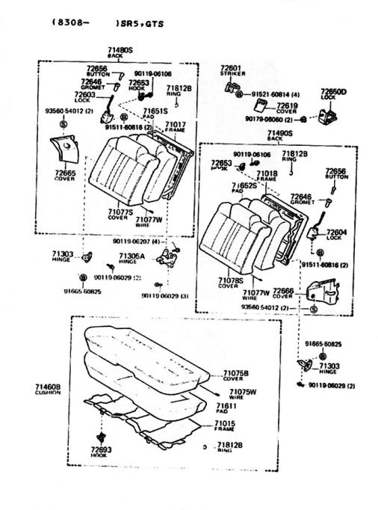
71017 Frame Sub-Assy, Rear Seat Back RH
Prod. Date | Model | Description | Part Number | Qty.
8608- | AE86.2D GTS |  | 71202-12100- | 1
8408- | AE86.2D GTS | W/ Sports Seat | 71202-12110- | 1
8408- | AE86.3D GTS | W/ Sports Seat | 71202-12090- | 1
71018 Frame Sub-Assy, Rear Seat Back LH
Prod. Date | Model | Description | Part Number | Qty.
8608- | AE86.2D GTS |  | 71203-12080- | 1
8408- | AE86.2D GTS | W/ Sports Seat | 71203-12090- | 1
8408- | AE86.3D GTS | W/ Sports Seat | 71203-12070- | 1
71075B Cover, Rear Seat Cushion (for Bench Type)
Prod. Date | Model | Description | Part Number | Qty.
8408-8508 | AE86.2D GTS | FB, Deep Maroon | 71065-1A350-02 | 1
8408-8508 | AE86.2D GTS | FB, Grey | 71065-1A350-03 | 1
8508-8608 | AE86.2D GTS | FB, Black | 71065-1A720-01 | 1
8508-8608 | AE86.2D GTS | FB, Blue | 71065-1A720-04 | 1
8605-8608 | AE86.2D GTS | FB, Black | 71065-1A721-01 | 1
8605-8608 | AE86.2D GTS | FB, Blue | 71065-1A721-04 | 1
8608- | AE86.2D GTS | FB, W/ Sports Seat, Black | 71065-1A722-01 | 1
8608- | AE86.2D GTS | FB, W/ Sports Seat, Blue | 71065-1A722-04 | 1
8608- | AE86.2D GTS | FB, Black | 71065-1A790-01 | 1
8608- | AE86.2D GTS | FB, Blue | 71065-1A790-04 | 1
8408-8508 | AE86.3D GTS | FB, Deep Maroon | 71065-1A340-02 | 1
8408-8508 | AE86.3D GTS | FB, Grey | 71065-1A340-03 | 1
8508-8608 | AE86.3D GTS | FB, Black | 71065-1A600-01 | 1
8508-8608 | AE86.3D GTS | FB, Blue | 71065-1A600-04 | 1
8605-8608 | AE86.3D GTS | FB, Black | 71065-1A601-01 | 1
8605-8608 | AE86.3D GTS | FB, Blue | 71065-1A601-04 | 1
8608- | AE86.3D GTS | FB, W/ Sports Seat, Black | 71065-1A602-01 | 1
8608- | AE86.3D GTS | FB, W/ Sports Seat, Blue | 71065-1A602-04 | 1
8608- | AE86.3D GTS | FB, Black | 71065-1A780-01 | 1
8608- | AE86.3D GTS | FB, Blue | 71065-1A780-04 | 1
71077S Cover, Rear Seat Back. RH
Prod. Date | Model | Description | Part Number | Qty.
8408-8508 | AE86.. GTS | FB, Deep Maroon | 71077-1H130-02 | 1
8408-8508 | AE86.. GTS | FB, Grey | 71077-1H130-03 | 1
8508-8608 | AE86.. GTS | FB, Grey | 71077-1H310-03 | 1
8508-8608 | AE86.. GTS | FB, Blue | 71077-1H310-04 | 1
8608- | AE86.. GTS | FB, W/ Sports Seat, Black | 71077-1H311-01 | 1
8608- | AE86.. GTS | FB, W/ Sports Seat, Blue | 71077-1H311-04 | 1
8608- | AE86.. GTS | FB, Black | 71077-1H490-01 | 1
8608- | AE86.. GTS | FB, Blue | 71077-1H490-04 | 1
71078S Cover, Rear Seat Back. LH
Prod. Date | Model | Description | Part Number | Qty.
8408-8508 | AE86.. GTS | FB, Deep Maroon | 71078-1A110-02 | 1
8408-8508 | AE86.. GTS | FB, Grey | 71078-1A110-03 | 1
8508-8608 | AE86.. GTS | FB, Grey | 71078-1A230-03 | 1
8508-8608 | AE86.. GTS | FB, Blue | 71078-1A230-04 | 1
8608- | AE86.. GTS | FB, W/ Sports Seat, Black | 71078-1A231-01 | 1
8608- | AE86.. GTS | FB, W/ Sports Seat, Blue | 71078-1A231-04 | 1
8608- | AE86.. GTS | FB, Black | 71078-1A290-01 | 1
8608- | AE86.. GTS | FB, Blue | 71078-1A290-04 | 1
71460B Cushion Assy., Rear Seat (for Bench Type)
Prod. Date | Model | Description | Part Number | Qty.
8508- | AE86.2D GTS | FB, Black | 71560-1A720-01 | 1
8508- | AE86.2D GTS | FB, Blue | 71560-1A720-04 | 1
8608- | AE86.2D GTS | FB, Black | 71560-1A721-01 | 1
8608- | AE86.2D GTS | FB, Blue | 71560-1A721-04 | 1
8508- | AE86.3D GTS | FB, Black | 71560-1A600-01 | 1
8508- | AE86.3D GTS | FB, Blue | 71560-1A600-04 | 1
8608- | AE86.3D GTS | FB, Black | 71560-1A601-01 | 1
8608- | AE86.3D GTS | FB, Blue | 71560-1A601-04 | 1
71480S Back Assy., Rear Seat, RH
Prod. Date | Model | Description | Part Number | Qty.
8508- | AE86.2D GTS | FB, Grey | 71480-1H480-03 | 1
8508- | AE86.2D GTS | FB, Blue | 71480-1H480-04 | 1
8608- | AE86.2D GTS | FB, Black | 71480-1H481-01 | 1
8608- | AE86.2D GTS | FB, Blue | 71480-1H481-04 | 1
8508- | AE86.3D GTS | FB, Grey | 71480-1H390-03 | 1
8508- | AE86.3D GTS | FB, Blue | 71480-1H390-04 | 1
8608- | AE86.3D GTS | FB, Black | 71480-1H391--01 | 1
8608- | AE86.3D GTS | FB, Blue | 71480-1H391-04 | 1
71490S Back Assy., Rear Seat, LH
Prod. Date | Model | Description | Part Number | Qty.
8508- | AE86.2D GTS | FB, Grey | 71490-1A350-03 | 1
8508- | AE86.2D GTS | FB, Blue | 71490-1A350-04 | 1
8608- | AE86.2D GTS | FB, Black | 71490-1A351-01 | 1
8608- | AE86.2D GTS | FB, Blue | 71490-1A351-04 | 1
8508- | AE86.3D GTS | FB, Grey | 71490-1A290-03 | 1
8508- | AE86.3D GTS | FB, Blue | 71490-1A290-04 | 1
8608- | AE86.3D GTS | FB, Black | 71490-1A291-01 | 1
8608- | AE86.3D GTS | FB, Blue | 71490-1A291-04 | 1
71651S Pad, Rear Seat Back, RH
Prod. Date | Model | Description | Part Number | Qty.
8408- | AE86..GTS | W/ Sports Seat | 71651-12410- | 1
71652S Pad, Rear Seat Back, LH
Prod. Date | Model | Description | Part Number | Qty.
8408- | AE86..GTS | W/ Sports Seat | 71652-12310- | 1
72619 Cover, Rear Seat Back Lock Stricker
Prod. Date | Model | Description | Part Number | Qty.
8308-8508 | AE86.. GTS | Deep Maroon | 72615-12030-02 | 2
8408- | AE86.. GTS | Black | 72615-12030-01 | 2
8508- | AE86.. GTS | Blue | 72615-12030-04 | 2
72646 Grommet, Rear Seat Back Stop Button
Prod. Date | Model | Description | Part Number | Qty.
8308-8508 | AE86.. GTS | Deep Maroon | 72646-12010-02 | 2
8408-8508 | AE86.. GTS | Grey | 72646-12010-03 | 2
8508- | AE86.. GTS | Black | 72646-12010-01 | 2
8508- | AE86.. GTS | Blue | 72646-12010-04 | 2
72656 Buton, Rear Seat Back Stop Release
Prod. Date | Model | Description | Part Number | Qty.
8308-8508 | AE86.. GTS | Deep Maroon | 72661-12010-02 | 2
8408-8508 | AE86.. GTS | Grey | 72661-12010-03 | 2
8508- | AE86.. GTS | Black | 72661-12010-01 | 2
8508- | AE86.. GTS | Blue | 72661-12010-04 | 2
For those interested in making your own seat cover replacements or are looking for a like original material, the following is a copy of a Toyota service bulletin, number 042, dated 01-30-87 for all models. Because this information is old there is no certainty that the companies exist or have any original materials available. The Toyota service bulletin is copied for your entertainment and enjoyment.
Title ORIGINAL TOYOTA SEAT COVER MATERIAL
Bulk replacement upholstery (vinyl and fabric) material is available from the following sources for most 1981-1985 Toyota models
Contract the listed distributor directly concerning availability of material for new model Toyota vehicles.
Lobel’s Auto Specialities, Inc.  680 Elmwood Avenue  Providence, RI 02907  Out of State Wats: 800-354-5420  Local: 401-781-1200 | Baltimore Textile Company  6200 Frankford Avenue  Baltimore, MD 21206  Local: 301-485-3260  MD Wats: 800-492-7030  National Wats: 800-327-4673
The Edward B. DeLeo Company  85 Fifth Avenue  Patterson, NJ 0754  (201) 684-3910 | Gulf Fabrics, Inc.  105 East Park Avenue  Tampa, FL 33602  813-223-1656
R. L. Johnson Co., Inc.  662 Myrtle Avenue  Boonton, NJ 07005  National Wats: 800-225-1089  Local: 201-263-3373 | Lobel’s Auto Uphostery & Supplies, Inc.  1245 West Sunrise Blvd.  Ft. Lauderdale, FL 33311  305-462-0707
Ka-Top Co., Inc.  1045 39th Steeet  Brooklyn, NY 11219  Local: 718-436-2922  National Wats: 800-221-0818-19  NY Wats: 800-535-2313 | Reliatex, Inc.  2846 Mercury Road  Jacksonville, FL 32207  904-733-9141
Ropat Fabrics Co., Inc.  1055 Utica Avenue  Brooklyn, NY 11203  Local: 718-498-8400  Wats: 800-221-6152 | Austin-Miami Fabrics  1108-A North Graham Street  Charlotte, NC 28206  Local: 704-332-2563  National Wats: 800-438-4124  NC Wats: 800-432-6437
Three Rivers Supply Company  477 West 7th Avenue  West Homestead, PA 15120  Local: 412-462-3900  PA Watts: 800-242-0397  National Wats: 800-245-0220 | Able Tops & Mats, Inc.  2312 South Indian Avenue  Chicago, IL 60616  312-225-8339
The Miami Rubber Company  720 Anderson Ferry Road  Cincinnati, OH 45238  513-451-6700 | Fabric Service, Inc.  1801 South Michigan Avenue  Chicago, IL 60616  312-326-2020
Maumee Fabrics Company  143 South St. Clair Street  Toledo, OH 43692  Local: 419-243-2191  OH Wats: 800-537-9299  National Wats: 800-537-0340 | Pyramid Trim Products, Inc.  576 North Prior Avenue  St. Paul, MN 55104  612-645-8126
Grubb & White  1120 Spring Garden Street  Philadelphia, PA 19123  215-763-9280-1-2 | America Upholstery Supply, Inc.  1355 North Marion  Tulsa, OK 74158  Local: 918-834-6691  OK Wats: 800-722-3932  National Wats: 800-331-3913
Gipson Trim Supply, Inc.  1515 West Main Street  Oklahoma City, OK 73106  405-235-2361 | Silver States Suppliers  240 East 6th South Street  Salt Lake City, UT 84110  801-328-0523
National Fabric Co., Inc.  901 South 7th Street  Kansas City, KS 66105  Local: 913-281-1833  KS Wats: 800-332-0155  National Wats: 800-821-7542 | Keyston Brothers  223 East Sixth South  Salt Lake City, UT 84110  801-521-0600
Walters Textiles  5796 Ferguson Road  Bartlett, TN 38134  Local: 901-388-0054  Wats: 800-238-3024 | Hedlund Fabrics & Supply Co.  1710 East Washington  Phoenix, AZ 85034  Local: 602-252-6058  AZ Wats: 800-352-5482  National Wats: 800-528-4564
Rushin Upholstery Supply, Inc.  2600 Welch  Little Rock, AR 72206  501-376-3196  501-376-3194 | Phoenix Trim & Supply Company  2359 North 33rd Avenue  Phoenix, AZ 85009  602-269-5825
Auto Fabs  1408 S. E. 12th  Portland, OR 97214  503-232-5862  503-232-4020 | Larry Dennis Company  5220 Laster Road  Ft. Worth, TX 76119  Local: 817-478-5461  TX Wats: 800-772-7542  National Wats: 800-433-7783
Industrial Rubber & Supply, Inc.  2307 East “D” Street  Tacoma, WA 98401  206-272-3244 | Southwest Fabrics, Inc.  514 South Hall Street  Dallas, TX 75226  Local: 214-742-1875  TX Wats: 800-492-6475  National Wats: 800-527-3420
Keyston Brothers  406 Evans Black Drive  Seattle, WA 98188  206-246-6771 | Coast Fabrics, Inc.  4400 Jensen Street  Oakland, CA 94601  415-261-8330
Denver Auto Trimming Supply Co.  2177 West 7th Avenue  Denver, CO 80204  Local: 303-825-0236  Wats: 800-525-6654 | G & G Fabrics, Inc.  4727 East Hedges  Fresno, CA 93703  209-252-8551
Boething Francis  1225 South Hope Street  Los Angeles, CA 90015  213-748-5564 | Keyston Brothers  9669 Aero Drive  San Diego, CA 92123  619-277-7770
References:
Toyota Microfiche, No. 41432-86, Parts Catalog, USA Canada AE86 Corolla
Toyota 1987 Technical Service Bulletins, P/N 00401-42844; Toyota Service Bulletin, Volume VIII; Reference, Body; Number, 042; Date, 01-30-87; Model, All Models; Title, Original Toyota Seat Cover Material

